

Nokia 1200

Description
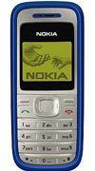
The Nokia 1200 mobile phone has been designed as a reliable, affordable and practical communications tool that helps you to get on with your day-to day business with the minimum of fuss.

STORE PRICE: Rs 1,298 /-
ONLINE PRICE: Rs 1,201 /-

Brand : Nokia
Model Name : 1200
Released Year : 2007
Phone Memory : No
External Memory : No
Colors : Blue, Black
Form : Bar
Dimensions : 102 x 44.1 x 17.5 mm
Weight : 77g

